

**<**

Contact:

**Angelo Virgilio**

[Angelo.virgilio@ecin.ca](mailto:Angelo.virgilio@ecin.ca)

Mobile: 416.605.1296

Wifi automation - mysql: INSTALLATION GUIDE

Bell Canada; ATL Lab

|  |
| --- |
| **Revisions** |

| Version | Primary Author(s) | Description of Version | Date Completed |
| --- | --- | --- | --- |
| 0.1  0.2 | Arijit Saha  Arijit Saha | First Draft version  Added ssh key generation and Database creation procedure | Jun 19, 2017  Jun 25, 2017 |

|  |
| --- |
| **Review & Approval** |

Requirements Document Approval History

| Approving Party | Version Approved | Signature | Date |
| --- | --- | --- | --- |
|  |  |  |  |
|  |  |  |  |

Requirements Document Review History

| Reviewer | Version Reviewed | Signature | Date |
| --- | --- | --- | --- |
|  |  |  |  |
|  |  |  |  |
|  |  |  |  |

|  |
| --- |
| **Table of Contents** |

01. Introduction 03

02. Hardware Requirements 04

03. Operating System Platform 04

04. Python Installation 04

05. Environmental variable setup for Python 07

06. Installing Python dependencies 10

07. Robot Framework installation and dependencies 16

08. Microsoft Visual C++ 2015 21

09. MySQL Server Installation 24

10. Workbench Installation 36

11. Database Security 38

12. Open SSH Installation 40

13. Generating ssh keys in Windows 43

14. WinSCP download and verification 47

15. Installation of .NET Framework 50

16. Creation of Database Schema, Tables and Views 52

1. **Introduction**

This document is the User Manual to install and configure the setup to support the ROBOT Automation framework. This document would outline all the Hardware and Software specifications and configurations. This document also aims to map the requirements

* 1. **Test Execution Flow**

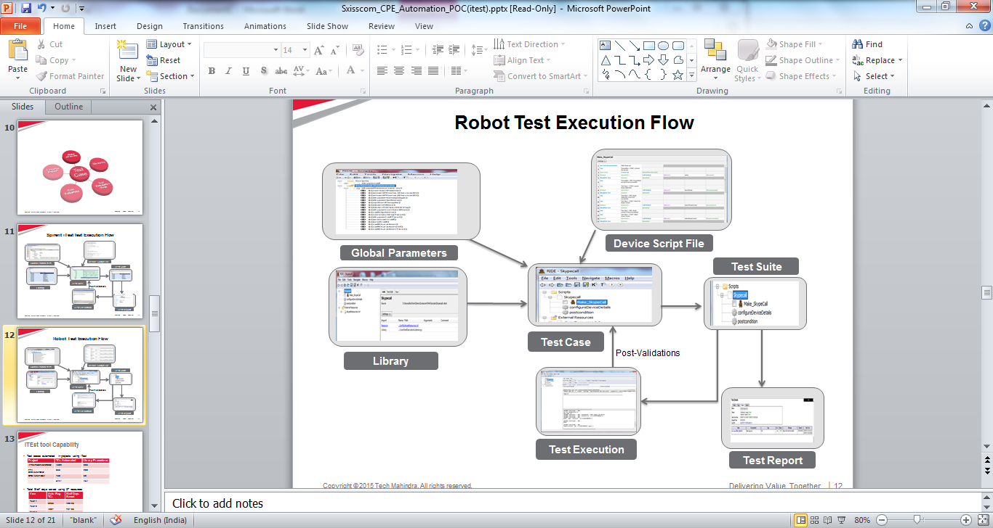

.

* 1. **References**

|  |  |
| --- | --- |
| **[R1]** | WaveTest User Guide Version 3.30 |
| **[R2]** | Wave Automation User Guide Version 4.6 |
| **[R3]** | Bell WiFi Automation Proposal V1-1.pdf |
| **[R4]** | WiFi Automation - MySQL Requirements and Design-V0.3.pdf |

1. **Installing Software and Applications**

* 1. **Hardware Requirements**
* The ROBOT Automation software should be given the resources as mentioned:

1. **500GB HDD**
2. **8GB RAM**
3. **2.4 GHZ** dual core processor

It should also be feasible to increase the RAM, processor speed for better performance and HDD for storage if required.

* 1. **Operating System Platform**
* The development environment will be set up on Windows server 2016. ROBOT Automation Framework is a platform independent application. To support the BELL wave automation solution, the ROBOT Automation solution must run on Windows10. The section would describe the process to Create Windows 10 Installation Media.
* The following link must be used to download and install a licensed version of Windows10- <https://www.microsoft.com/en-in/software-download/windows10>
* Additional patch to enable multiple parallel logins would be used for multiple users to login in parallel.
* After installation, create a user in Windows OS named “**Bell**” and provide password “**bell**”.
  1. **Python Installation**
* Robot Framework is supported on [Python](http://python.org/), [Jython](http://www.jython.org/) and [IronPython](http://ironpython.codeplex.com/). The interpreter you want to use should be installed before installing the framework. For the Bell Wave Automation solution, the Robotframework must be run using the Python installer. This section describes the detailed process to install the Python and relevant packages to support Robot framework.

1. Download the Python 2.7.8 installer from <https://www.python.org/download/releases/2.7.8/>.

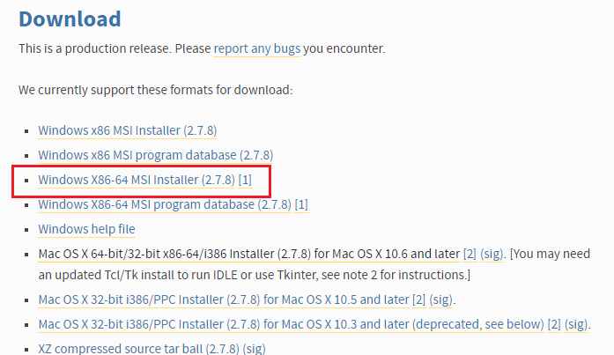

1. Run the installer, select “Install for all users,” and then click “**Next**.” The installer will even set the path variable.

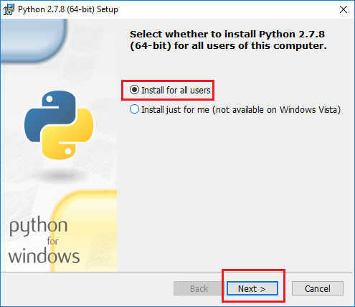

1. On the directory selection screen, keep the installation directory as “**C:\Python27\**” and click “**Next**.”

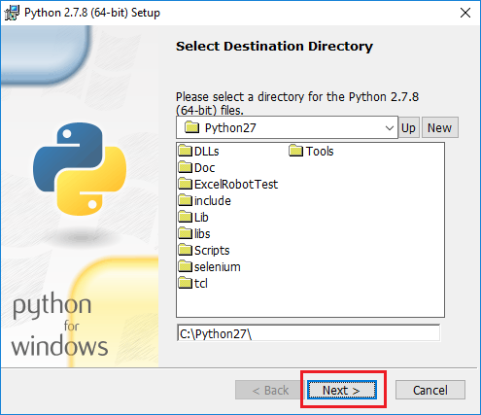

1. On the customization screen, scroll down, to check the options for installing and then click “**Next**”.

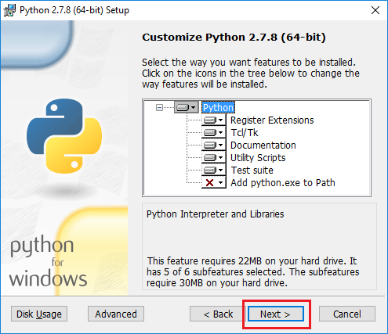

1. Then click “**Finish**” once the installation is complete.
   * 1. **Setting up Environmental Variables for Python**

When using Python on UNIX-like machines both Python itself and scripts installed with should be automatically in PATH and no extra actions needed. On Windows and with other interpreters PATH must be edited and configured manually. This is a one-time configuration which needs to be done.

On Windows you can configure PATH by following the steps below. Notice that the exact setting names may be different on different Windows versions, but the basic approach is still the same

Hit Start, type “advanced system settings,” and then select the “View advanced system settings” option. In the “System Properties” window that opens, on the “Advanced” tab, click the “Environment Variables” button.

1. Open Start > Settings > Control Panel > System > Advanced > Environment Variables. There are User variables and System variables and the difference between them is that User variables affect only the current users, whereas System variables affect all users.

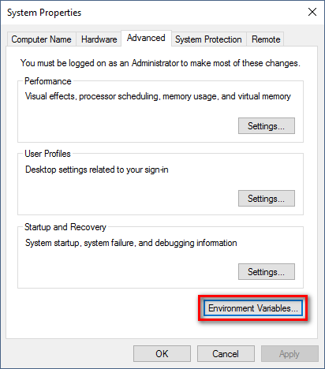

1. Find the “**Path**” variable under “**System Variables**” and select it.

After selection, click “**Edit**”. A window will open for where the path variables will be listed. Adding new path variable and editing existing variables can be done.

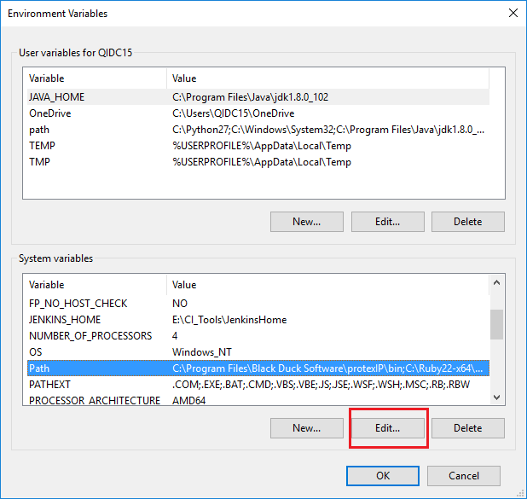

1. Click “**New**” button and enter data in the format

Enter “**C:\Python27**”.

Again click “**New**” and enter “**C:\Python27\Scripts**”.

Click “**Ok**”

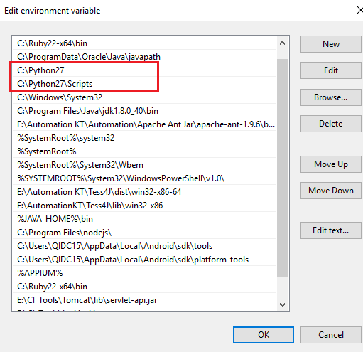

1. From command prompt, type “**python –version**” to make sure that Python has been installed properly.

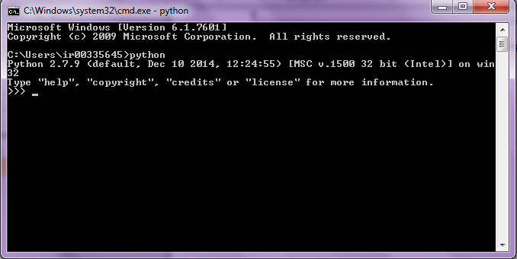

* 1. **Install wxPython 2.8.12.1**

wxPython is a **GUI toolkit** for the [Python](http://www.python.org/) programming language. It allows Python programmers to create programs with a robust, highly functional graphical user interface, simply and easily. It is implemented as a Python extension module (native code) that wraps the popular [wxWidgets](http://wxwidgets.org/) cross platform GUI library. Followng section describes the process to install lthewxPython and the specific version supported.

1. Download the wxPython installer from <https://sourceforge.net/projects/wxpython/files/wxPython/2.8.12.1/>
2. Open the link and click on “**wxPython2.8-win64-unicode-2.8.12.1-py27.exe**”

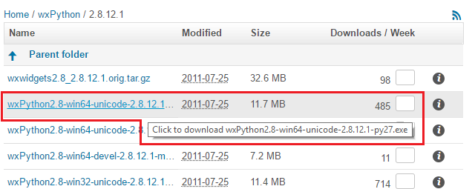

1. Run the installer and click “**Next**” to continue the setup.

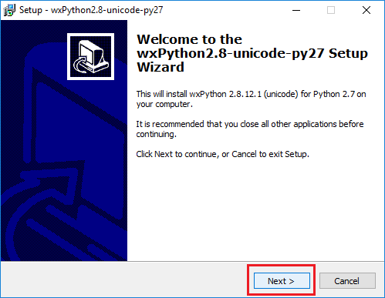

1. In the window, click on radio button to accept the terms of agreement.

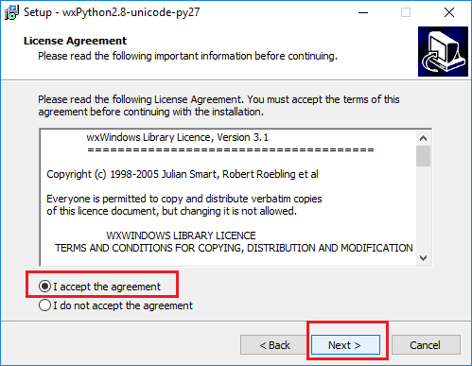

1. Click “**Next**” after keeping the default directory “**C:\Python27\Lib\siti-packages**” chosen for the installation for this program.

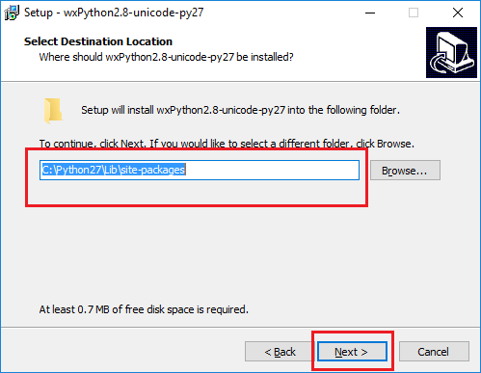

1. Click on “Next” after selecting “**Full Installation**” from the drop down and selecting the checkbox for “**Make this install be the default wxPython**”.

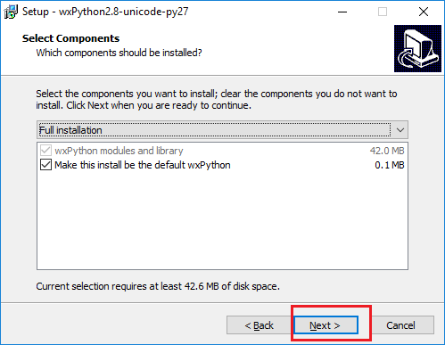

1. The installation process will follow and complete after this.

A command line interface will open and the installation will continue.

If the “**ReadMe.txt**” file is open, then close it.

* 1. **Install setuptools 28.6.1**

Setuptools is a package development process library designed to facilitate packaging Python projects by enhancing the Python standard library distutils (distribution utilities).

1. Download setuptools from <https://pypi.python.org/pypi/setuptools/28.6.1>.
2. Scroll down and click the link to download the setuptools zipped folder.

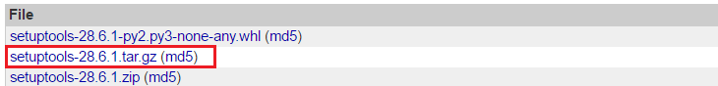

1. Unzip the download folder in “**C:\Users\Bell**” and the extracted folder “**C:\Users\Bell\setuptools-28.6.1**” should have the contents as follows:

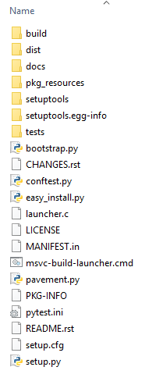

1. Open the command line and browse by changing directory to the extracted folder and type “**python setup.py install**”

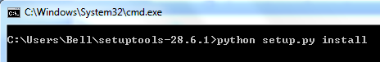

1. The entire setup will run and the message will appear which will show the successful installation of setuptools.

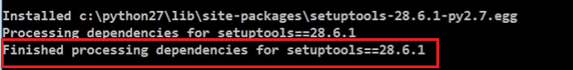

* 1. **Install pip 9.0.1**

As a popular open source development project, Python has an active supporting community of contributors and users that also make their software available for other Python developers to use under open source license terms.

Pip is the preferred installer program.

1. Download pip from <https://pypi.python.org/pypi/pip>?
2. Scroll down and click the link to download the pip zipped folder.

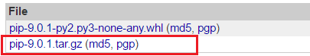

1. Unzip the download folder in “**C:\Users\Bell**” and the extracted folder “**C:\Users\Bell\pip-8.1.2**” should have the contents as follows:

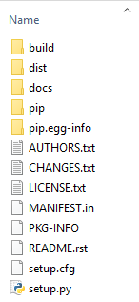

1. Open the command line and browse by changing directory to the extracted folder and type “**python setup.py install**”

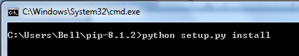

1. The entire setup will run and the message will appear which will show the successful installation of pip.

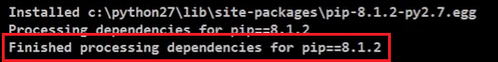

* 1. **Install robot framework 3.0.2**

Robot Framework is a generic open source test automation framework. Its testing capabilities can be extended by test libraries implemented either with Python or Java, and users can create new higher-level keywords from existing ones using the same syntax that is used for creating test cases. It is operating system and application independent.

1. Open the command prompt and browse to “**C:\Users\Bell**” and type in “**pip install robotframework**”



1. The successful message will be shown after installation.

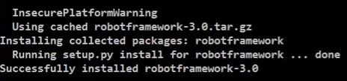

* + 1. **Install robot framework – RIDE**

RIDE is the integrated development environment which will help develop test scripts with Python, execute them and get the results in visual format on screen to the tester. It is based on wxPython.

1. Open the command prompt and browse to “**C:\Users\Bell**” and type in “**pip install robotframework-ride**”



1. The successful message will be shown after installation.



1. Create a shortcut of RIDE on the desktop by opening the folder “**C:\Python27\Scripts**” and right-click on “**ride.py**”.

After the popup menu appears, select “**Send to**” and select “Desktop **(create shortcut)**”

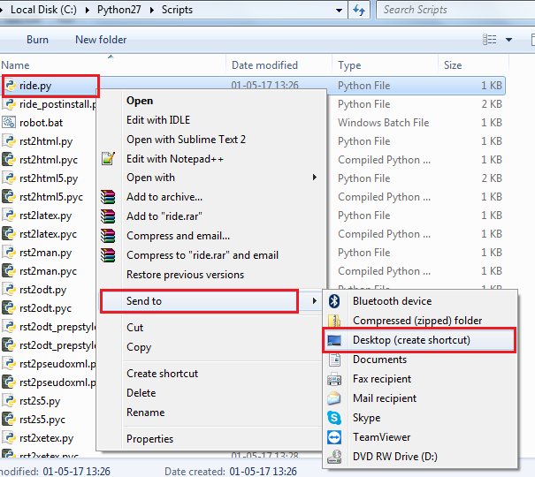

1. Rename the created shortcut to “**ROBOTAutomation RIDE.**”

Double click on shortcut icon to open the RIDE window.

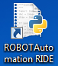

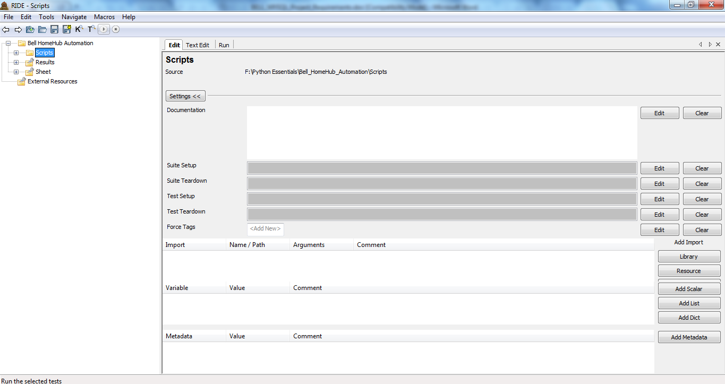

**2.7.2 Install paramiko**

This is a library for making SSH2 connections (client or server). Emphasis is on using SSH2 as an alternative to SSL for making secure connections between python scripts

1. Open the command prompt and browse to “**C:\Users\Bell**” and type in “**pip install paramiko**”



1. The successful message will be shown after installation.



**2.7.3 Install docutils**

Docutils is a modular system for processing documentation into useful formats, such as HTML, XML, and Latex. For input, Docutils supports Restructured text, an easy-to-read, what-you-see-is-what-you-get plaintext markup syntax.

1. Open the command prompt and browse to “**C:\Users\Bell**” and type in “**pip install docutils**”



1. The successful message will be shown after installation.



**2.7.4 Install pymysql**

This package contains a pure-Python MySQL client library. Transactions to the database will be executed with the help of this package.

1. Open the command prompt and browse to “**C:\Users\Bell**” and type in “**pip install pymysql**”.

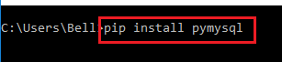

1. The successful message will be shown after installation.

C:\Users\ARION\Downloads\pip4.png

**2.7.5 Install pigments**

It is a generic syntax highlighter suitable for use in IDE’s, forums, wikis or other applications that need to prettify the source code.

1. Open the command prompt and browse to “**C:\Users\Bell**” and type in “**pip install pigments**”.



1. The successful message will be shown after installation.



**2.7.5 Install SCPClient**

A library that implements the client side of the scp (Secure Copy) protocol. It is designed to be used with paramiko.

1. Open the command prompt and browse to “**C:\Users\Bell**” and type in “**pip install SCPClient.**



1. The successful message will be shown after installation.



**2.7.6 Install scp**

A library that implements the client side of the scp (Secure Copy) protocol. It is designed to be used with paramiko.

1. Open the command prompt and browse to “**C:\Users\Bell**” and type in

“**pip install scp”.**



1. The successful message will be shown after installation.



1. **Install Microsoft Visual C++** 
   1. **Microsoft Visual C++ 2015 Redistributable**
2. Click on link to download Visual C++ Redistributable 2015 <https://www.microsoft.com/en-in/download/details.aspx?id=48145>

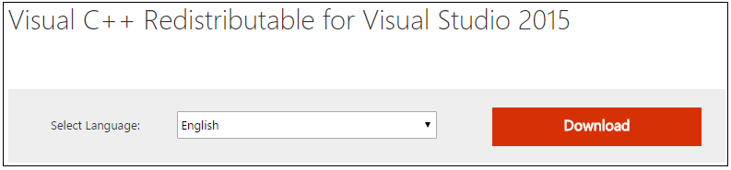

1. Choose the version based on the operating system. (Example shows for **64 bit** version)

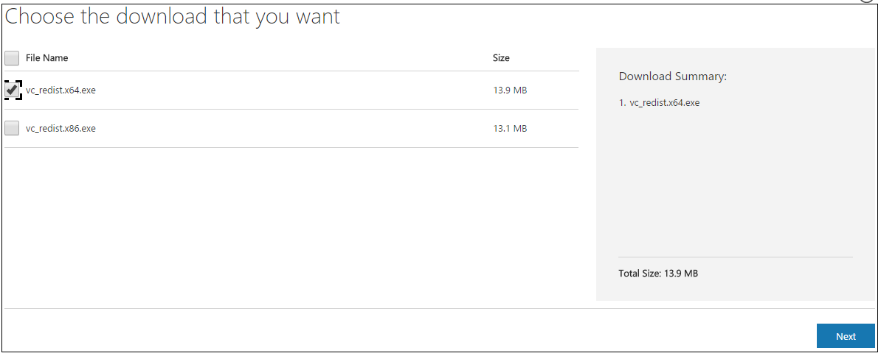

1. Run the installer, click on checkbox to agree to agreement and click “**Install**”.

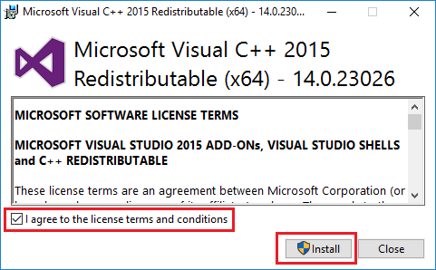

**3.2 Microsoft Visual C++ 2013 Redistributable**

a. Click on link to download Visual C++ Redistributable 2013

<https://www.microsoft.com/en-in/download/details.aspx?id=40784>

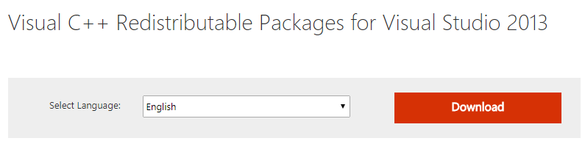

b. Choose the version based on the operating system. (Example shows for **64 bit** version)

Click next after selection and the downloading of the file will start.

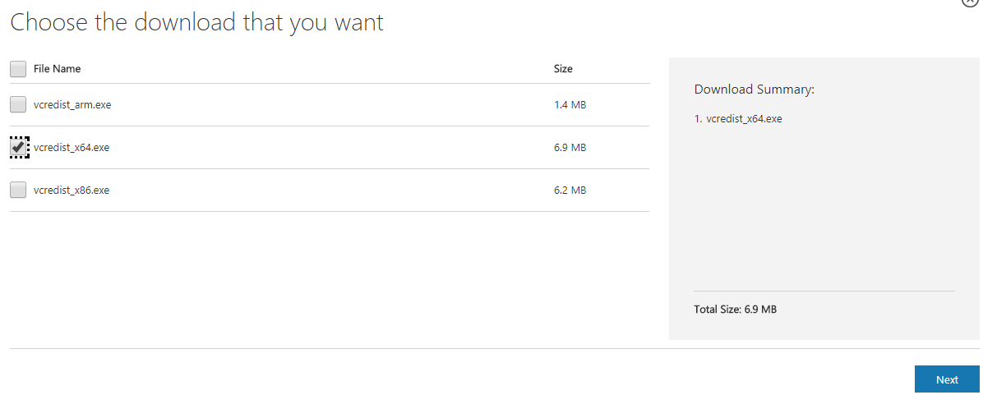

1. Run the installer, click on checkbox to agree the agreement and click “**Install**”

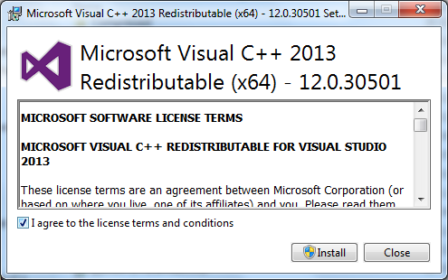

1. **Install MySQL server**
2. Click on link to download the installer <https://dev.mysql.com/downloads/installer/>
3. Choose the web community installer as shown below for MySQL

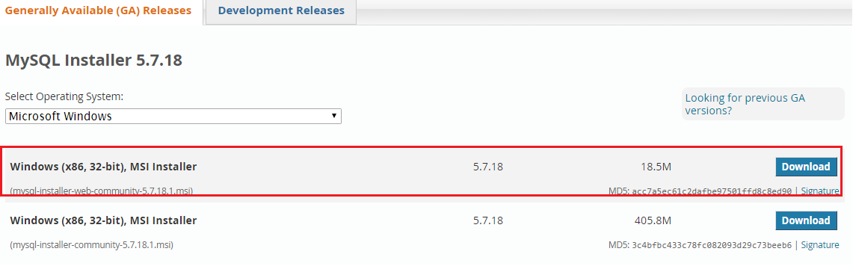

1. Choose to download without sign in.

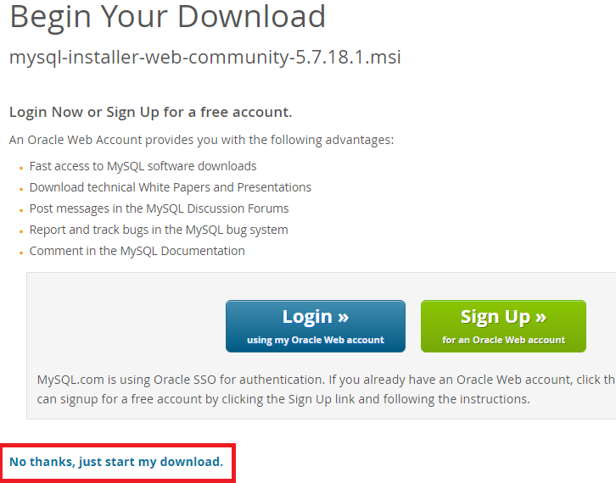

1. Run the installer downloaded.

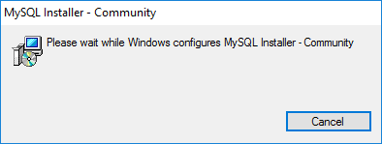

1. Click on checkbox to accept the license terms and click on “**Next**” button to proceed to installation.

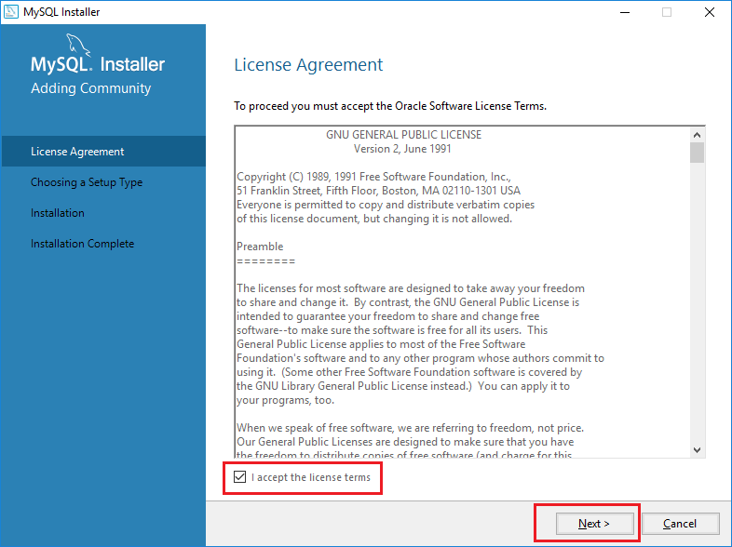



1. Choose the “**Custom**” option for the list of options and click “**Next**”.

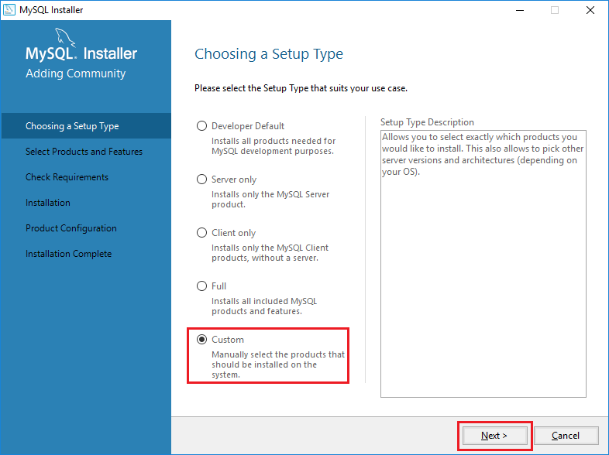

1. From the list of products available, choose **MySQL server** based on the operating system version.

Click on the “**Green**” arrow after selecting the server version as shown in the picture below.

(Example shows **64bit version** installation)

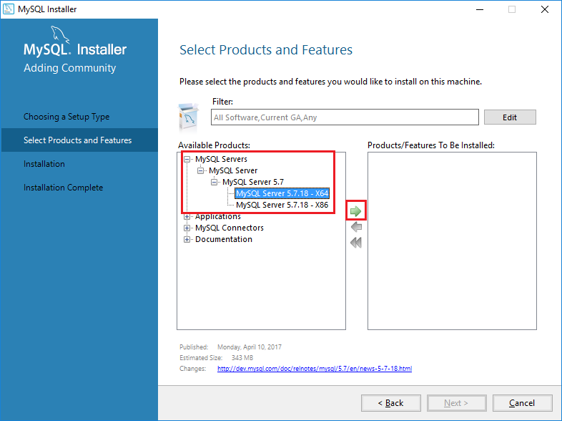

1. From the list of products available, choose **MySQL Workbench 6.3** and click on “**Green**” arrow.

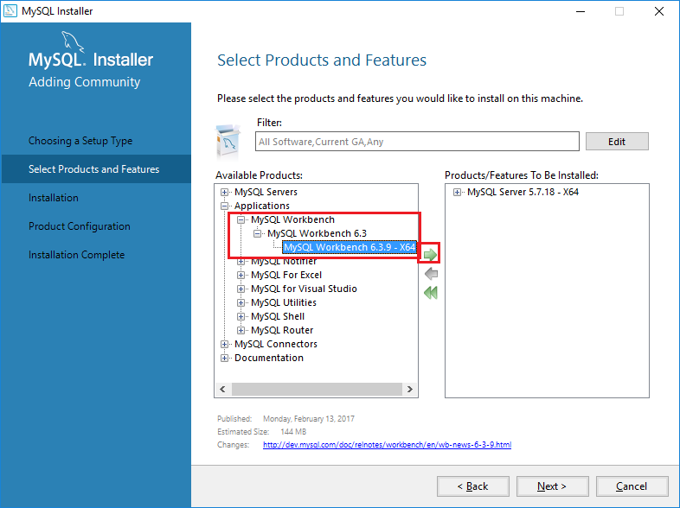

1. From the list of products available, choose **MySQL Connectors** and choose **Connector/Python.**

Expand the list of connector for Python and choose for connector for **Python 2.7** for specific operating system version. (Example shows for **64 bit** version).

Click on “**Green”** arrow.

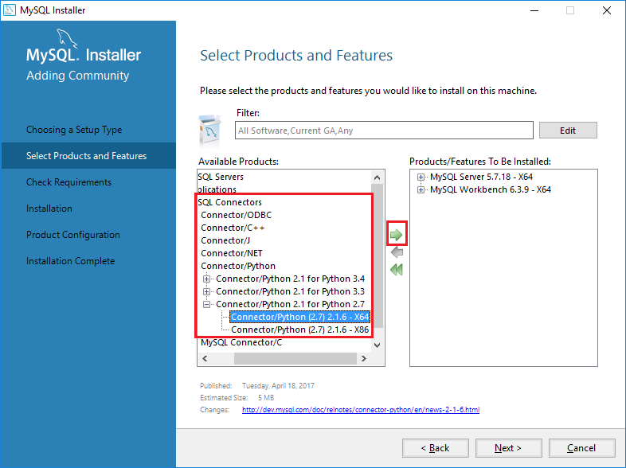

1. After selecting the products to be installed, click “**Next**”.

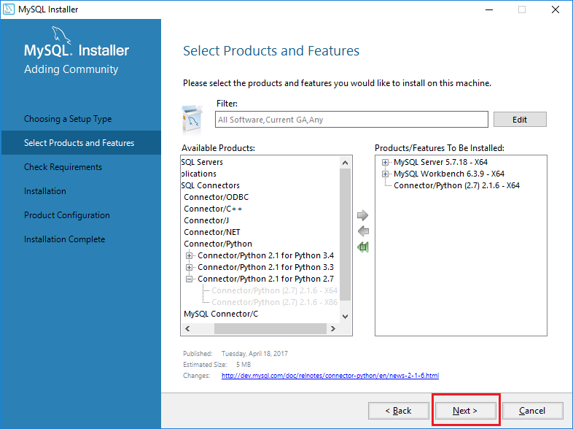

1. Check for the products enlisted for installation and click “**Execute**”.

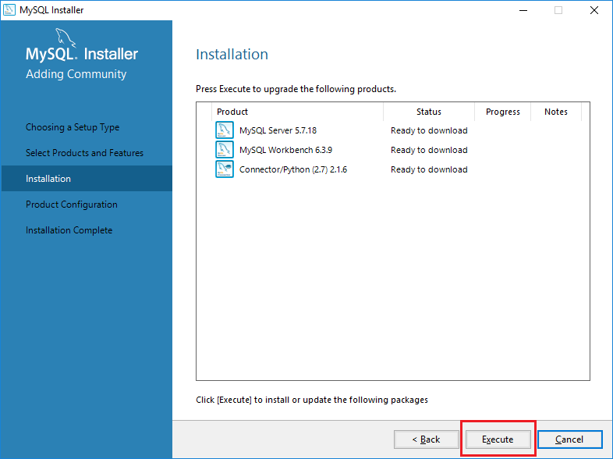

1. After the products to be installed gets downloaded, and the status column shows “**Complete**” click “**Next**”.

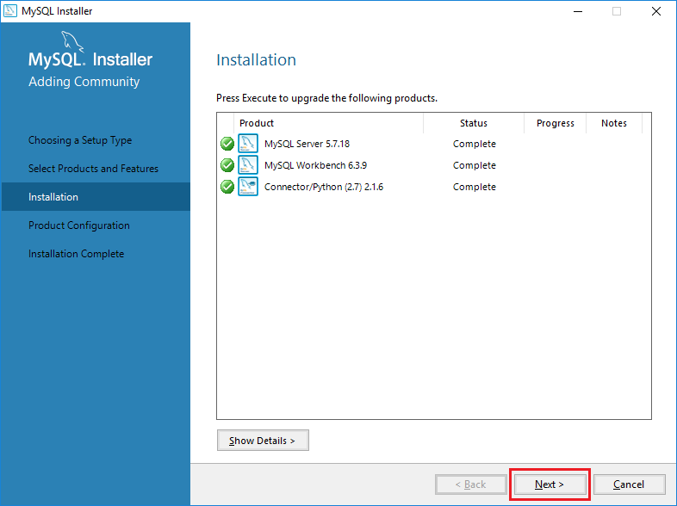

1. Status “**Ready to Configure**” will start the configuration of MySQL server on the workstation. Click “**Next**”.

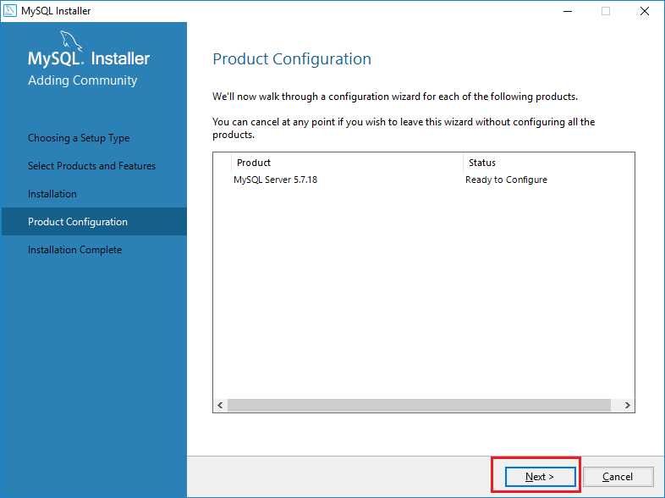

1. Choose the “**Standalone MySQL server**” for the Type of server to be installed.

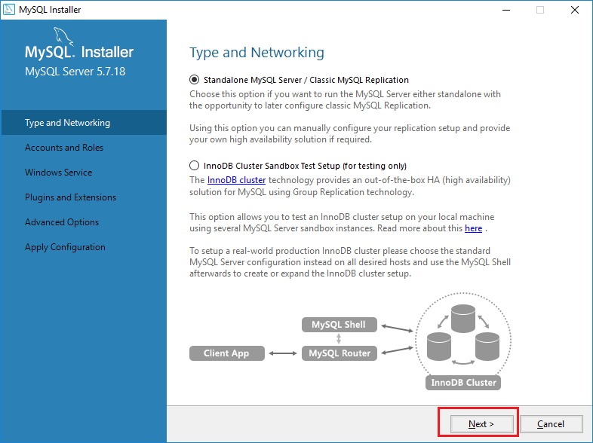

1. From the Server Network configuration page, change the **port** and **firewall options** if required or keep the default settings. Click “**Next**”.

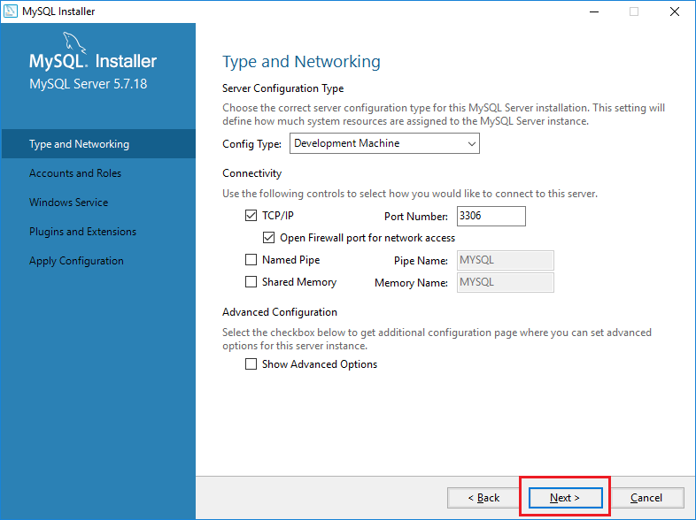

1. Enter password “**bell**” for the root user and click “**Next**”.

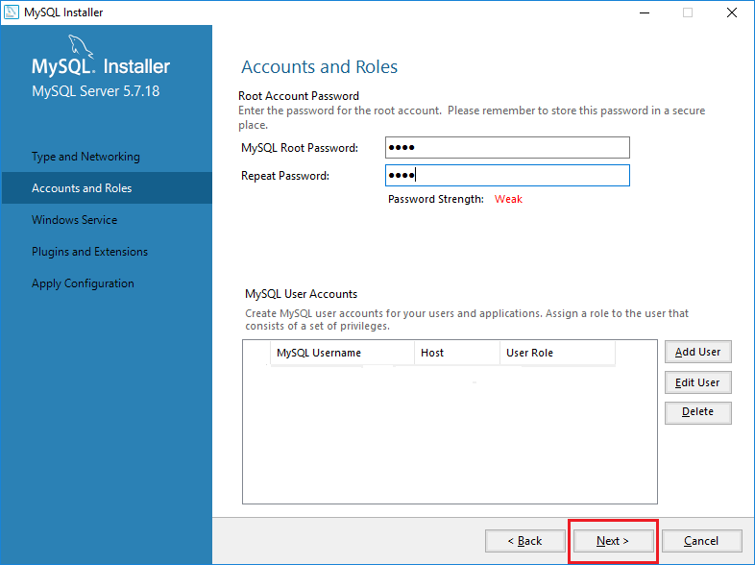

1. Click on checkbox to choose the MySQL server as Windows service.

Enter “**MySQL57**” in service name field.

Choose the **“Standard System Account”** option for Windows Service.

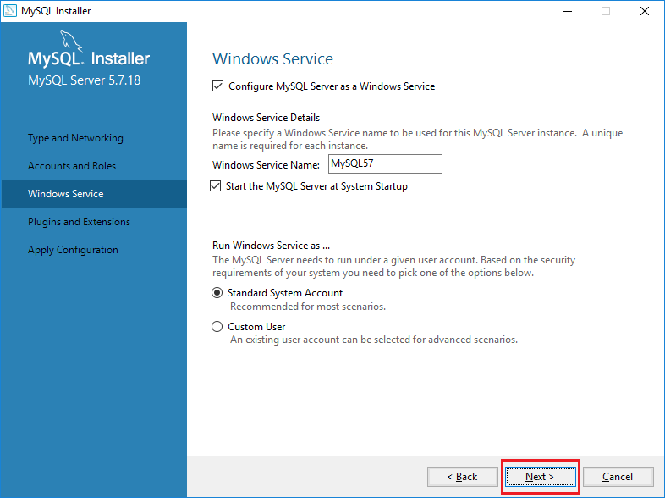

1. Click “**Next**” on ‘Plugins and Extensions’ page.

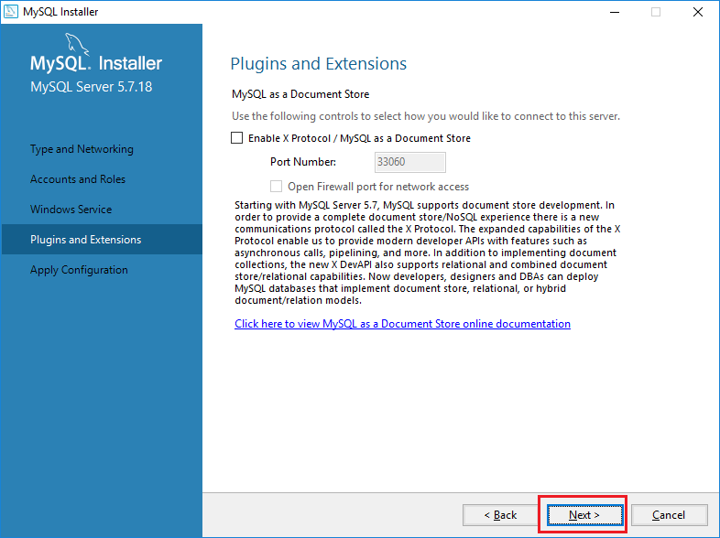

1. Click “**Execute**” to apply the configuration changes.

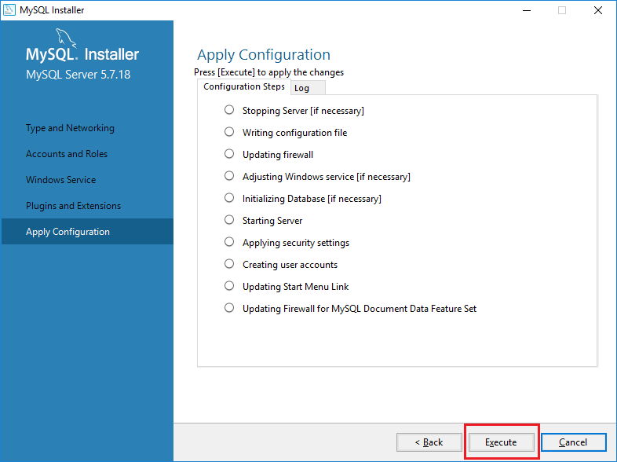

1. Click “**Finish**” to apply the installation configuration.

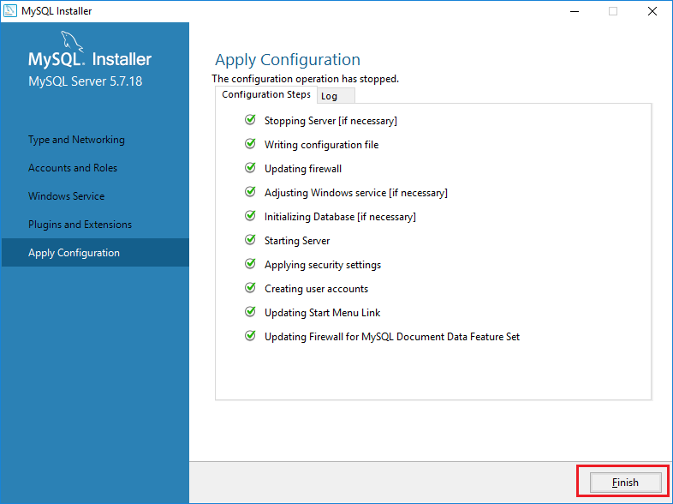

1. Click “**Next**” to apply the configuration changes.

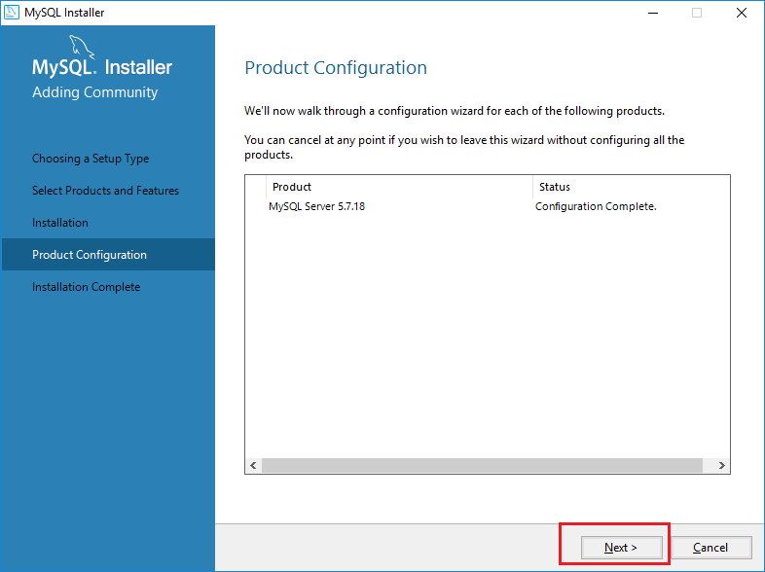

1. Click “**Finish**” to complete the installation.

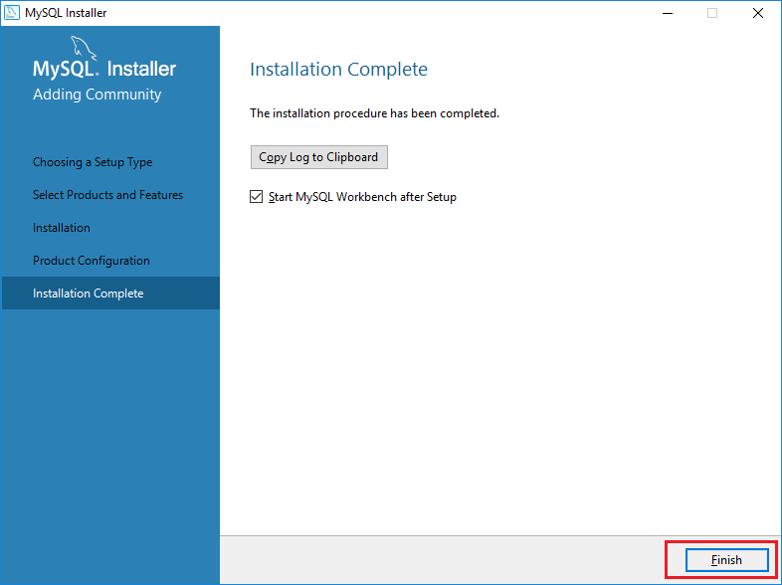

**Setting Environment Variables for MySQL**

1. Open Start > Settings > Control Panel > System > Advanced > Environment Variables. There are User variables and System variables and the difference between them is that User variables affect only the current users, whereas System variables affect all users.



1. Find the “**Path**” variable under “**System Variables**” and select it.

After selection, click “**Edit**”. A window will open for where the path variables will be listed. Adding new path variable and editing existing variables can be done.



1. On the pop-up window that appears, enter “**C:\Program Files\MySQL\MySQL Server 5.7\bin**”.

Click “**Ok**”.

1. **Workbench Installation**
2. Open the “**C:\Program Files\MySQL\MySQL Workbench 6.3 CE**”

Right-click on the file “**MySQLWorkbench.exe**” and after the popup menu appears click “**Send to**”.

Click “**Desktop (create shortcut)**” to create a shortcut of the application.

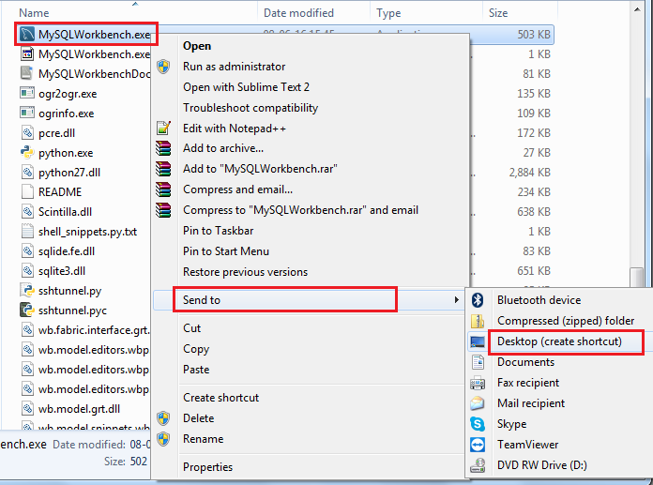

1. Rename the shortcut created to “MySQLWorkbench.”

Click on shortcut to open the MySQL Workbench GUI.

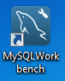

1. Click “**root**” instance to open the schemas.

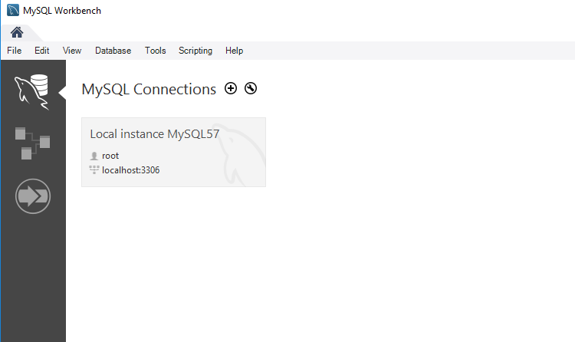

1. Enter the password in the field as “**bell**”.

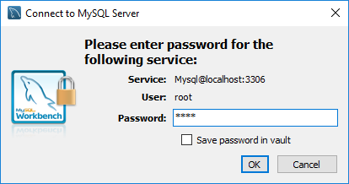

1. **Database Security : Defining Users**
2. Login using ‘**root’** id and create new user for automation.
3. On the Workbench, click “**Users and Privileges**”.

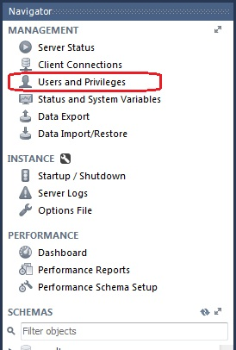

1. Click on Add Account.



1. Enter details for new user as “**autotest1**” in the login name field.

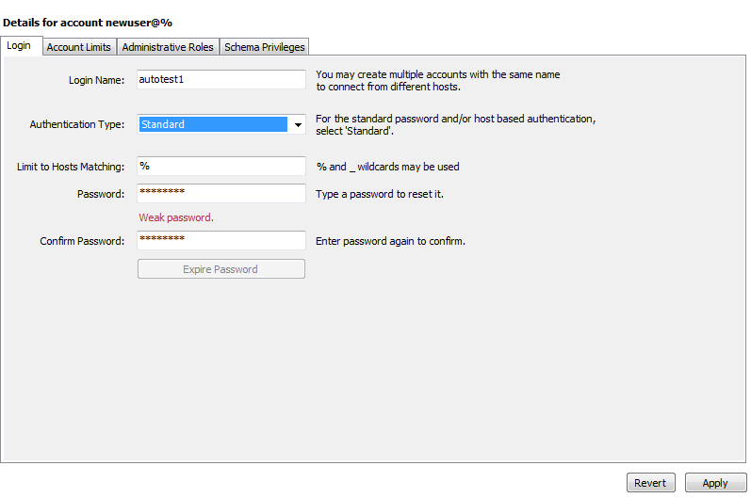

1. Assign the permissions and access levels for the user as **INSERT**, **CREATE**, **UPDATE**.

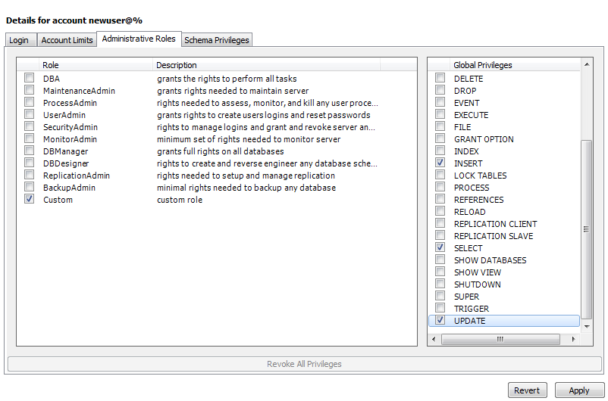

1. **OpenSSH Installation**

OpenSSH is the premier connectivity tool for remote login with the SSH protocol. It encrypts all traffic to eliminate intrusions and ensure safety. In addition, OpenSSH provides a large suite of secure tunneling capabilities, several authentication methods, and sophisticated configuration options. Remote operations are done using ssh, scp and sftp using the OpenSSH suite.

1. Download the OpenSSH installer from <https://sourceforge.net/projects/sshwindows/>
2. Extract the downloaded .zip folder to “**C:\Users\Bell**”.
3. Double click on “**setup.ssh**” file to open the installation window. Click “**Next**”.

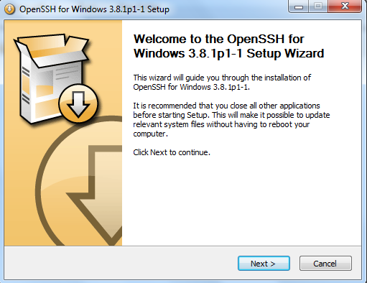

1. Click on radio button to Accept terms and click “**Next**”.

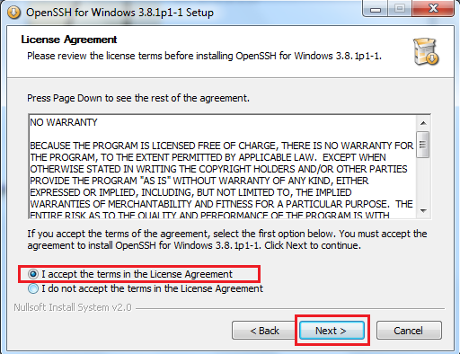

1. Keep the default components as shown to be installed and click “**Next**”.

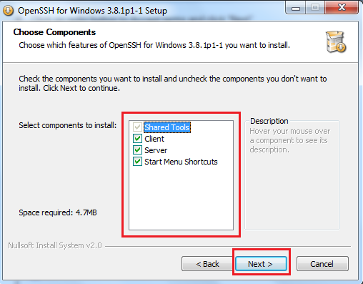

1. Select the destination folder as “**C:\Program Files(x86)\OpenSSH**” and click “**Next**”.

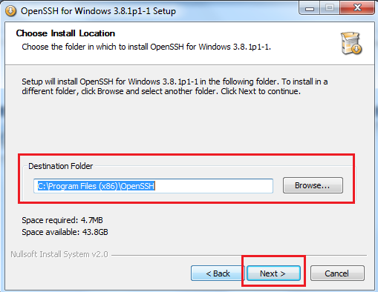

1. Click “**Install**” button to start the process.

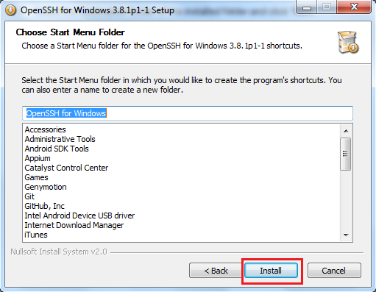

1. **Generating ssh keys in Windows**

**Note**: Generation of keys is account/user specific and should not be shared among the accounts/users. If there are multiple accounts/users on the host machine, ssh keys should be created for each account/user specifically. Only the public key of each account/user is to be copied to the remote machine.

1. Download putty key generator from <https://www.chiark.greenend.org.uk/~sgtatham/putty/latest.html>
2. From the link above, download the respective executable named as **puttygen.exe** based on operating system version.

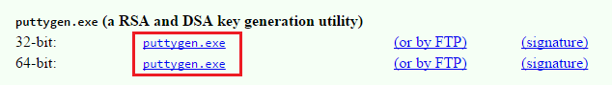

1. If “**.ssh**” folder is not present under “**C:\Users\Bell\**”, then create the folder from command prompt using “**md .ssh**” command.

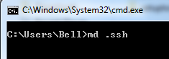

1. After the download completes, copy the executable file to “**C:\Users\Bell**” and open it. The key generator window will open and click “**Generate**” button.

For **Type of key to generate**, select **RSA**.

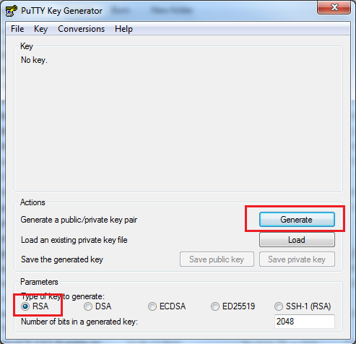

1. Move your mouse in the area below the progress bar. When the progress bar is full, the key pair gets created.

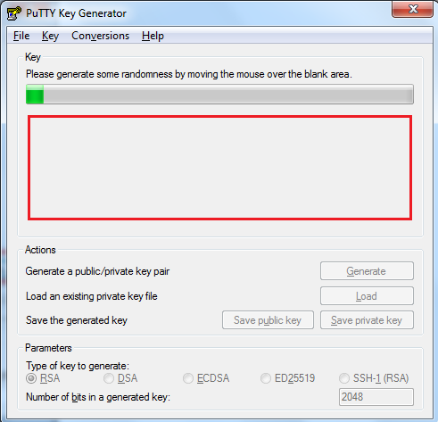

1. Click the **Save private key** button to save the private key as it will be required for connection later.

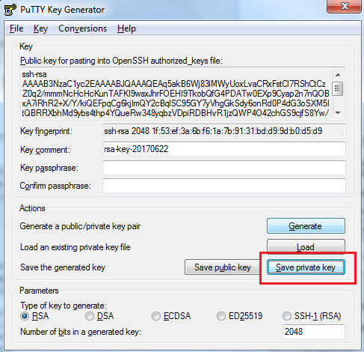

1. Click “**Yes**” button on the warning, as the setting passphrase is not suitable for automation purpose.

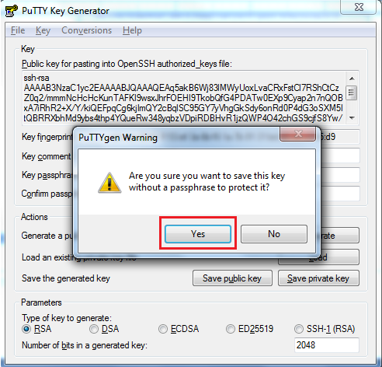

1. Enter a name for the “**.ppk**” file and save it in the “**C:\Users\Bell\.ssh**” folder.
2. Right-click in the text field labeled **Public key for pasting into OpenSSH authorized_keys file** and choose **Select All.**
3. Right-click again in the same text field and choose **Copy**.

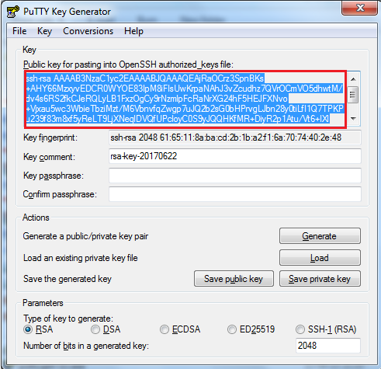

1. Open an editor and paste the selected data which can later be used to configure public key on server. Save with extension “**.pub**” file under “**All Files**” in “**C:\Users\Bell\.ssh**” folder.



1. Login in to the remote machine (the remote server to which the host will be connecting to) and check for **.ssh** folder in “**C:\Users\Bell\**”.

1. If “**.ssh**” folder is not present under the user account **Bell** in the remote machine, then create the folder from command prompt, by first navigating to **C:\Users\Bell**\ by using command “**cd** **C:\Users\Bell\**” and then using “**md .ssh**” command.
2. Now create **authorized_keys** folder inside **C:\Users\Bell\.ssh** by command “**md authorized_keys**”.
3. **WinSCP download and verification**

WinSCP is an open source free SSH client for Windows with the focus on secure file transfer. WinSCP supports SFTP (SSH File Transfer Protocol) for secure file transfers. In addition to that it also supports legacy SCP (Secure Copy Protocol). You can use WinSCP to transfer files both manually and automatically.

**Note:** This is being used for development activity and will be replaced by SSH library tools.

1. Download **WinSCP** portable from <https://winscp.net/eng/download.php>.
2. Click on “**Portable Executables**” option to download “**.zip**” file.

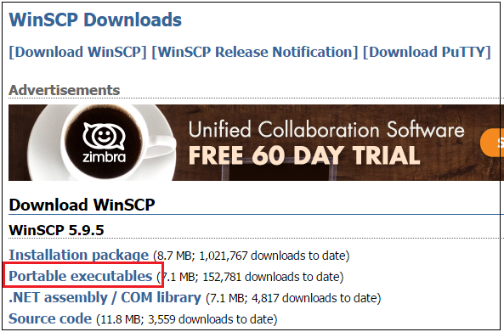

1. After download completes, extract the .zip folder. The contents of the folder will be as shown. The contents of the unzipped folder will be used for the following steps and there is no manual installation process to be followed.

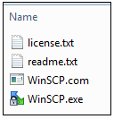

1. Open the **WinSCP.exe** file and enter the details for **Hostname**, **Username** and **Password** fields.

Click “**Login**”.

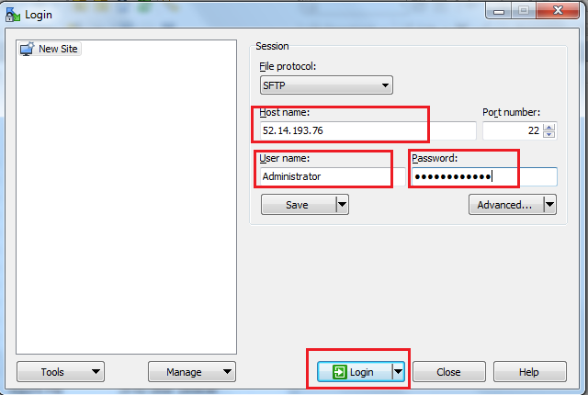

1. Click “**Yes**” to support the connection establishment by saving the host key to cache.

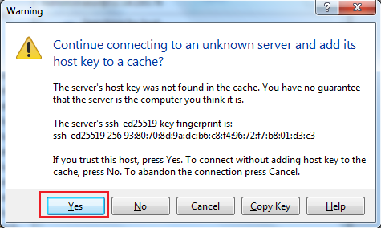

1. After the saving the keys as shown above, the progress for the connection establishment would be shown.

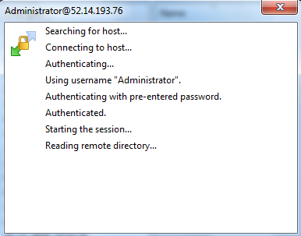

1. After connection establishment, the window of host and remote would be shown.

Now transfer the **.pub** file saved in the **.ssh** folder of host machine to the “**C:/Users/Bell/Desktop**” of remote machine.

**Note**: Later the file needs to be moved from Desktop to **.ssh/authorized_keys** folder of remote machine as WinSCP does not allow connection to **.ssh/authorized_keys** for security.

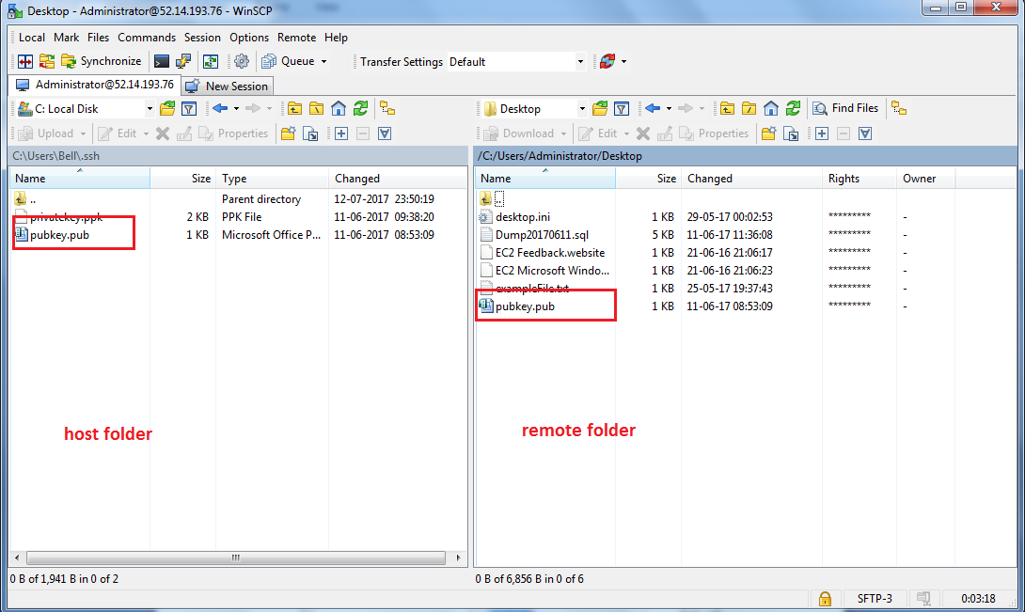

1. **Installation of .NET framework**
   1. Click **Start** and then select **Control Panel**.

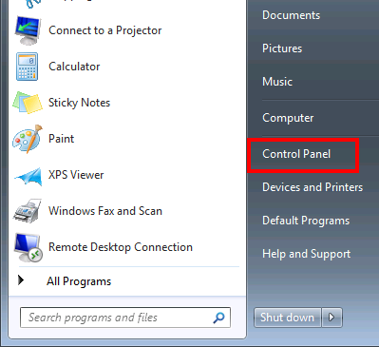

* 1. Click on Programs.

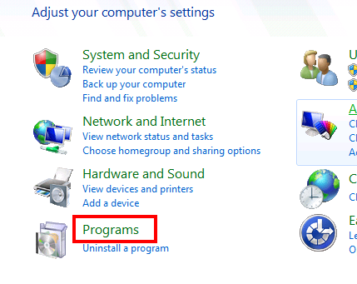

* 1. Click on **Turn Windows feature on or off** in Programs and Features.

Control Panel Programs

* 1. Click on checkbox beside Microsoft .NET Framework 3.5.1

The checkbox will become filled after selecting the specific option.

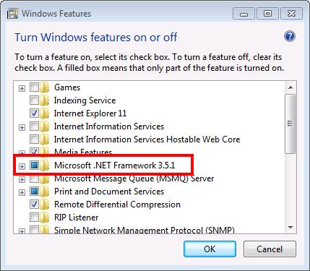

* 1. Click **Ok** to save the settings.

Wait for Windows to complete the installation and click **Yes** if it asks to download Windows Updates.

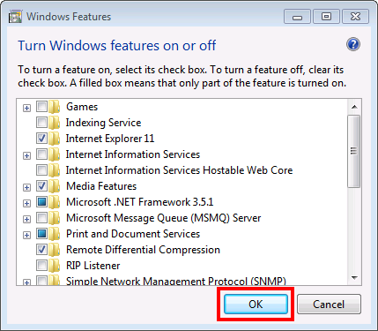

1. **Creation of Database Schema, Tables and Views**.
   1. Copy the “**Bell HomeHub Automation DB Creation.zip**” provided along the document to root folder “**C:\**”.
   2. Extract the folder to “**C:\**” as shown.

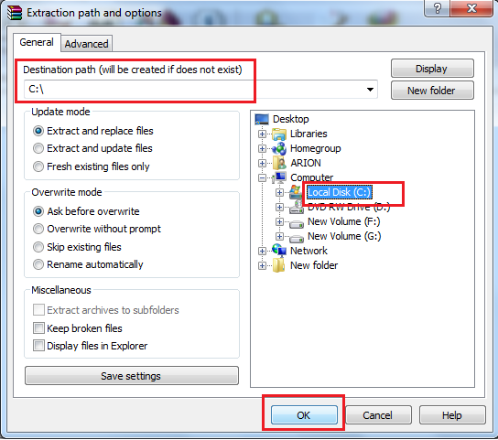

* 1. Open the extracted folders and there must a file called “**createDBscript.py**” in “**C:\Bell HomeHub Automation\tools**”

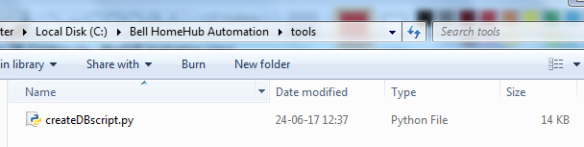

* 1. Open the command line and browse by changing directory to “**C:\Bell HomeHub Automation\tools**” and type in “**python createDBscript.py**”

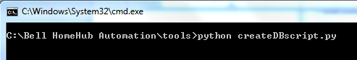

* 1. The execution of the command will create the schema, tables and views.

Open the Workbench using the shortcut in the desktop

Provide the credentials to the root user and to view the created structure.

There should be **8 tables for results** schema and **10 tables for master**.

There should be **5 views** for each schema.

